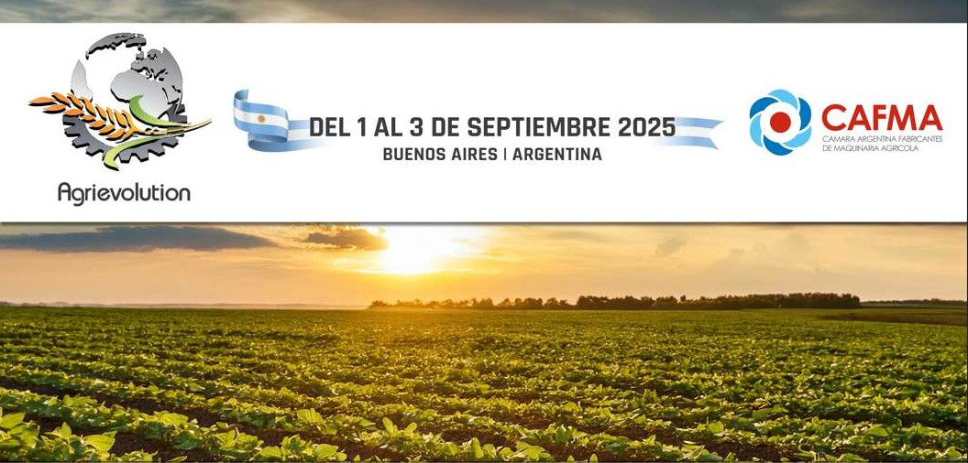

**Agrievolution Eighth World Summit on Agriculture:**

**ACHIEVING FOOD SECURITY and SUSTAINABLE AGRICULTURE thru MECHANIZATION and PRECISION TECHNOLOGIES**

**September 1-3, 2025 ~ Buenos Aires, Argentina**

# DAY 1- MONDAY SEPTEMBER 1

**9:00-10:00 OPENING AND WELCOME**

* *Charlie O’Brien, Secretary General, Agrievolution*
* *Enrique Bertini, President, CAFMA*
* *Gerardo Werthein, Ministry of Foreign Affairs (invited)*
* *Sergio Iraeta, Argentina Secretary of Agriculture (invited)*
* *Daniel Tillard, President, National Bank of Argentina*

# 10:00-10:45 AGRICULTURE CONSERVATION IN ARGENTINA:

# EXPERIENCE AND PRACTICE

* *Nicolas Bronzovich, President, Argentina National Institute of Agricultural Technology*
* *Marcelo Torres, President, Argentina No Till Farmers Association (AAPRESID)*

Moderator: Ignacio Ruiz, Chair, Agrievolution and Secretary General, National Association for Agricultural, Forestry and Landscaping Machinery (Spain)

# 10:45-11:15 BREAK

# 11.15–12:15 SMART FARMING AND AGTECH: IMPROVING PRODUCTION AND ENVIRONMENTAL CONSERVATION

* *Kemal Shoshi, President, Representative Director, YANMAR AGRIBUSINESS Co., Ltd.*
* *Marnix Doorn, Project Manager, Argentine-German Dialogue for Sustainable Agricultural Innovations*
* *Gustavo Oberto, President, Global Irrigation, Lindsay Corporation*
* *Konrad Harbort, Founder, Corvus Consulting and German Farmer*

Moderator: Curt Blades, Agrievolution Board Member & Senior Vice President, Association of Equipment Manufacturers (USA)

**DAY 1- MONDAY SEPTEMBER 1 (continued)**

# 12:15-13:15 LUNCH

**13:30-14:30 AGRICULTURE CONSERVATION AND CARBON SEQUESTRATION:**

**ROLE OF MECHANIZATION**

* *Miguel Angel Taboada, Specialist, Argentina National Institute of Agricultural Technology (INTA)*
* *Julián Martínez Quijano, Chair, Argentine Maize and Sorghum Association*
* *Martin Biscaisaque, Chair, ArgenTrigo*
* *Joao Morales Soa, Direct Planting, Brazil*

Moderator: Ruth Bailey, Agrievolution Board Member and Secretary General, Agricultural Engineers Association (UK)

# 14.30-16.00 FARMER SUCCESS STORIES FROM AROUND THE WORLD

* *Pedro Vigneau, Argentina Farmer:* Mechanization/Precision Agriculture in Argentina
* *Jorge Lopez Menedez, Farmer in Africa:* Need and Opportunity for Mechanization in African Agriculture
* *Stefan Cramm, German Farmer and DLG Committee on Farm Management*

Moderator: Mary Boote, Agrievolution Strategic Partner and CEO, Global Farmer Network

**16.00-16.15 Closing**

Charlie O’Brien, Secretary General, Agrievolution

**19.30 – 21.00 Gala Dinner**

**DAY 2 – TUESDAY, SEPTEMBER 2**

**9:00-9:15 Welcome**

Charlie O’Brien, Secretary General, Agrievolution

**9.15–10.00 Keynote**

Beth Bechdol, Deputy Director General, Food and Agriculture Organization of the United Nations (FAO) (Invited)

# 10:00-11:00 CHALLENGES OF ACHIEVING GLOBAL FOOD SECURITY

* *Beth Bechdol, Deputy Director General, Food and Agriculture Organization of the United Nations (FAO)* (Invited)
* *Dr. Julio Calzada, Economist, Rosario Stock Exchange (BCR)*

Moderator: Alessandro Malavolti, CEO, AMA and President, Agrievolution

**DAY 2 - TUESDAY SEPTEMBER 2 (continued)**

**11:00-11:30 Break**

# 11.30-12:30 SILOBAG SYSTEM STORAGE: A LOGISTIC SOLUTION AND PROFITABLE TOOL

* *Ricardo Bartosik, PhD, Researcher & Extension Engineer, Argentina National Institute of Agricultural Technology (INTA)*
* *Sebastián Calderón, Foreign Trade Manager, Carlos Mainero y Cia*
* *Lucia Martinez, Director, Martinez y Staneck*

Moderator: *To be Determined*

**12:30-13:30 Lunch**

# 13:30-15:00 FUTURE OF AGRICULTURE MECHANIZATION AND PRECISION AGRICULTURE TECHNOLOGIES

* *Matteo Vanotti, CEO/Co-Founder, Matteo Cunial, CRO/Co-Founder or Miguel Cordoba, Director of LATAM, xFarm Technologies*
* *Carlo Lambro, Brand President, New Holland Agriculture*
* *Andrew Olliver, Chairman, Agriculture Industry Electronics Foundation (AEF) and Global Precision Technology Partner Manager, CNHI*
* *TR Kesavan, President/CEO, TAFE Ltd.*

Moderator: *To be Determined*

# 15:00-15:15 CLOSING

* *Charlie O’Brien, Secretary General, Agrievolution*
* *Carlos Braga and Enrique Bertini, CAFMA*

**15.30 – 17.00 Buenos Aires Tour (optional)**

**DAY 3 – WEDNESDAY SEPTEMBER 3: FIELD DAY**

# 08:30 BUS DEPARTURE TO FARM FIELD

**10:00-12:00 SUSTAINABLE FARMING BEST PRACTICES: Presentation and**

**Demonstration**

**12:00-14:00 LUNCH**

**14:00-16:00 LIVE EQUIPMENT DEMONSTRATIONS**

**16:30 RETURN TO BUENOS AIRES**

**5-7-25**